# Q1. WAP to print the LCM and the HCF of two positive integers. Be careful about all exceptional cases. Define two separate functions to calculate LCM and HCF respectively.

//A*B = LCM * HCF

#include <stdio.h>

#include <stdlib.h>

int hcf(int a,int b)

{

if(a>b)

{

int div=b;

int r=1;

do{

r=a%div;

a=div;

div=r;

}

while(r!=0);

//TAKE EXAMPLE OF 20 12 TO EXPERIENCE THE FUNCTIONING

return a;

}

else{

int div2=a;

int s=1;

do{

s=b%div2;

b=div2;

div2=s;

}

while(s!=0);

return b;

}

}

void lcm(int a,int b)

{

printf("LCM of %d and %d is %d\n",a,b,(a*b)/hcf(a,b));

}

int main()

{

int a,b;

// printf("Enter any two numbers : ");

scanf("%d %d",&a,&b);

lcm(a,b);

printf("HCF of %d and %d is %d",a,b,hcf(a,b));

return 3;

}

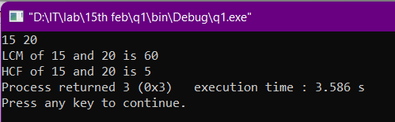

# Q2. WAP that prints the temperature converted from the input unit to the other two units. The units possible are Celsius (C), Fahrenheit (F), and Kelvin (K).

#include <stdio.h>

#include <stdlib.h>

void cel(int c)

{

printf("\nCelsius Conversions-->");

printf("\nValue of %d in Fahrenheit is %.2f\n",c,((9/5.0)*c)+32.0);

printf("Value of %d in Kelvin is %d\n",c,273+c);

}

void fah(int f)

{

printf("\nFahrenheit Conversions-->");

printf("\nValue of %d in Celsius is %.2f\n",f,(5/9.0)*(f-32));

printf("Value of %d in Kelvin is %.2f\n",f,273.0+(f-32.0)*(5/9.0));

}

void kel(int k)

{

printf("\nKelvin Conversions-->");

printf("\nValue of %d in Celsius is %.2f\n",k,k-273.0);

printf("Value of %d in Fahrenheit is %.2f\n",k,32.0+(k-273)*(9/5.0));

}

int main()

{

int c,f,k;

printf("Enter Temperature values in C_F_K respectively : ");

scanf("%d %d %d",&c,&f,&k);

cel(c);

fah(f);

kel(k);

return 3;

}

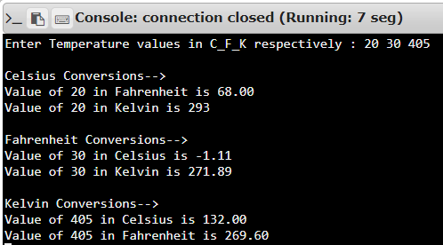

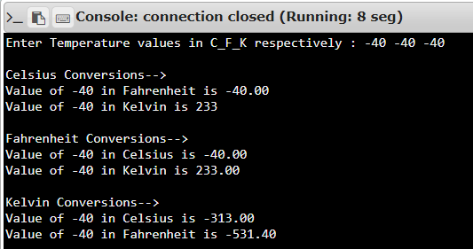

# Q3. WAP to calculate the roots of a quadratic equation when its coefficients are provided as inputs. Remember the cases to be considered and print imaginary numbers in the "(a) + (b)i" format.

#include <stdio.h>

#include <stdlib.h>

#include <math.h>

int main()

{

int a,b,c;

float D,p,q;

//printf("Enter values of the coefficient a,b,c respectively --> ");

scanf("%d %d %d",&a,&b,&c);

//printf("The equation is %dx2 + %dx + %d = 0\n",a,b,c);

D=(b*b)-(4*a*c);

if(D>=0){

p = (-b+pow(D,0.5))/(2.0*a);

q = (-b-pow(D,0.5))/(2.0*a);

if(p==q){

printf("The roots are real-and-equal.\n");

printf("They are: (%f) each.",p);

}

else{

printf("The roots are real-and-distinct.\n");

printf("They are: (%f) and (%f)",p,q);

}

}

else{

printf("The roots are imaginary.\n");

printf("They are: (%f) + (%f)i and (%f) - (%f)i",-b/(2.0*a),(pow(-D,0.5))/(2*a),-b/(2.0*a),(pow(-D,0.5))/(2*a));

}

return 3;

}

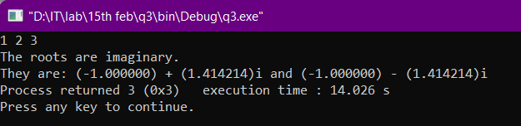

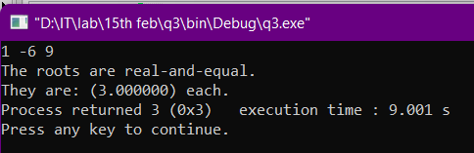

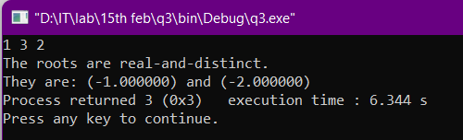

# Q4. WAP to print all the prime factors of a given number. Assume that no negative number will be given as input. Use user-defined functions.

#include <stdio.h>

#include <stdlib.h>

#include <math.h>

void prime(int a)

{

//LOOP CONTINUES TILL a BECOMES AN ODD NUMBER

while(a%2==0){

printf("2 ");

a=a/2;

}

for(int i=3;i<=pow(a,0.5);i+=2){

while(a%i==0){

printf("%d ",i);

a=a/i;

}

}

if(a>2) printf("%d ",a);

}

int main()

{

int num;

//printf("Enter the number --> ");

scanf("%d",&num);

if(num>1){

printf("The prime factors of %d are:\n",num);

prime(num);

}

else printf("Number should be larger than 1.");

return 3;

}

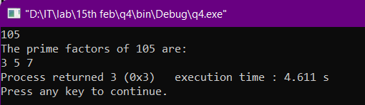

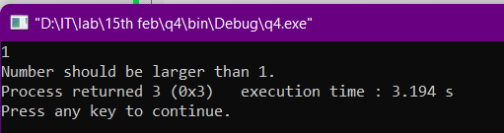

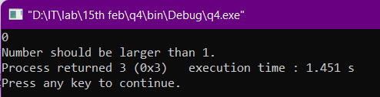

# Q5. WAP to reverse a number and check if it is a palindrome. A palindrome is any set of characters that reads the same when reading in the forward as well as the backward direction. Eg. 123321, 7658567, 242.

#include <stdio.h>

#include <stdlib.h>

int reverse(int a)

{

int b=a;

int result=0,q,r;

do{

q = a/10;

r = a%10;

result = (result*10) + r;

a=a/10;

}

while(q!=0);

printf("Reversed number is %d.\n",result);

if(b==result) printf("%d is a palindrome.",b);

else printf("%d is not a palindrome.",b);

return 0;

}

int main()

{

int num=0;

//printf("Enter any number --> ");

scanf("%d",&num);

reverse(num);

return 3;

}

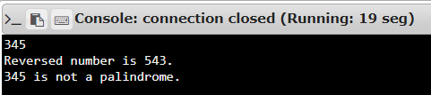

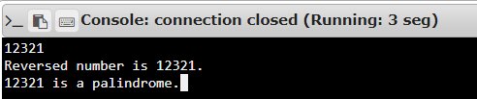

# Q6. Write a program to print the factorial of a number via TWO functions: one that uses a normal loop and one that uses recursion.

#include <stdio.h>

#include <stdlib.h>

int fact(int a)

{

if(a==0||a==1) return 1;

else return a*fact(a-1);

}

int main()

{

int num;

//printf("Enter the number --> ");

scanf("%d",&num);

int product=1;

if(num!=0){

for(int i=1;i<=num;++i){

product*=i;

}

printf("Factorial by simple function is %d.\n",product);

}

else printf("Factorial by simple function is 1.\n");

printf("Factorial by recursion is %d.",fact(num));

return 3;

}

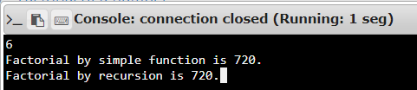

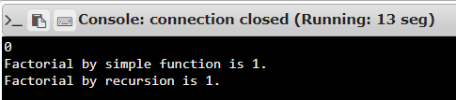

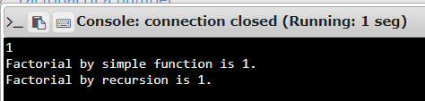

# Q7. WAP to search and print the location (position) of the FIRST occurrence of an element in a 10-element array. If it is not found, then print that it is not found.

#include <stdio.h>

#include <stdlib.h>

int main()

{

int arr[11];

//printf("Give the input inside the arr[10] and last element as the search element --> ");

for(int i=0;i<11;++i){

scanf("%d",&arr[i]);

}

int s=arr[10];

int count=1;

for(int j=0;j<10;++j){

if(s==arr[j]){

printf("%d is first found at the %d-th position.",s,count);

break;

}

++count;

}

if(count==11) printf("%d is not found",s);

return 3;

}



 